Section 1 - Meta information
Team: Volkan Senguller , Mehmet Keklik
Our project: Variety of Flavour (Prosjekt for Nettstedsdesign)
Sprint number: Projektledelse Sprint 1 Sprint 2 Sprint 3 Sprint 4 Sprint 5 Overlevering
Schedule: Starting time: 29.01.2024 - End time: 25.04.2024
Section 2 – Sprint planning note
2.1. Sprint goals
Projektledelse: Our goal is to achieve successfully the objectives of the project within the constraints of time, budget, and resources while meeting stakeholder expectations.
Sprint 1: In this Sprint, we aim to establish key project management processes such as defining roles and responsibilities, setting up communication channels, and creating a project plan to ensure a solid foundation for the project.
Sprint 2: During this Sprint, our focus is on creating the initial design mockups and starting the development of essential project features, such as user authentication and basic navigation, laying the groundwork for the project's functionality.
Sprint 3: In Sprint 3, we will iterate on the design, development, and testing processes, incorporating feedback from stakeholders and ensuring that all deliverables meet the specified requirements and quality standards.
Sprint 4: During this Sprint, our objective is to fine-tune the project's functionality, improve the user experience based on usability testing results, and prepare for the final delivery.
Sprint 5: In the last Sprint, we will focus on polishing the project, performing final testing to ensure everything functions as expected.
Project Handover: During the project handover phase, our objective is to present the fully completed project , provide comprehensive documentation and ensure that all loose ends are tied up for a successful closure of the project.

2.2. Definition of done
- All user stories included in the sprint are implemented and meet acceptance criteria.
- Code review conducted and approved by team members.
- Unit tests are written for all new code and pass successfully.
- Integration tests are executed and pass without failures.
- User acceptance testing (UAT) is performed and approved by stakeholders.
- Documentation, including user manuals and technical specifications, is updated.
- Code is merged into the main branch of the version control system.
- Continuous integration (CI) pipeline runs successfully, including automated builds and tests.
- Performance tests are conducted and meet predefined performance targets.
- Security checks are performed, and vulnerabilities are addressed.
- All identified bugs and issues are fixed or appropriately logged for future resolution.
- Product backlog is updated with any new insights or changes arising from the sprint.
- Sprint review meeting conducted with stakeholders, and feedback is incorporated.
- Sprint retrospective meeting held to discuss lessons learned and improvements for the next sprint.
- Product Owner approves the completion of the sprint and marks it as ready for production deployment.

2.3. Sprint backlog items
Item Id | Item description | Size Estimation | Customer value
SB01 | As a site admin I can develop homepage layout and design | 13 | High
SB02 | As a site visitor I can implement user authentication and registration | 5 | Medium
SB03 | As a site admin I can create database schema for menu items | 5 | Medium
SB04 | As a site member I can design wireframes for menu customization feature | 8 | Medium
SB05 | As a site member I can integrate social media sharing functionality | 5 | Medium
SB06 | As a site admin I want to be able to implement search functionality for menu items | 15 | High
SB07 | As a site member I can develop user profile pages for saving preferences | 8 | Medium
SB09 | As a site member I can create landing page for promotional events | 5 | Medium
SB10 | As a site admin I want to be able to implement backend functionality for order processing | 5 | Medium

2.4. Kanban management board
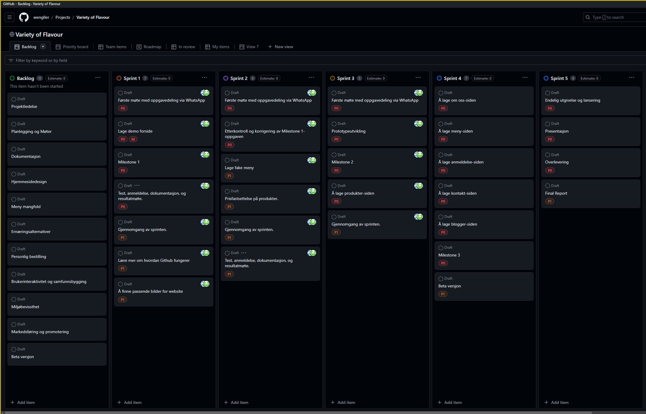

Section 3 – Sprint Review note
3.1. Reflective summary
Participants: Volkan, Mehmet
Meeting duration, location: 1,5 hours, zoom
Summary of what is discussed: During the sprint review, Volkan and Mehmet discussed the progress and status of the user stories. The team addressed the completion status of each user story and identified any issues or challenges encountered during the sprint.

Demonstration result:

Item Id | Item description | Estimation | Status | Demo
U01 | As a site admin I can define project scope, objectives, and timeline. | 12 | Finished | No
U02 | As a site admin I want to be able to create a project timeline and sprint plan for reference. | 15 | Finished | Yes
U03 | As a site member I can integrate filters and tags for halal, vegetarian, vegan, and gluten-free options. | 5 | Untouched | No
U04 | As a site member I want to be able to collect feedback from stakeholders and make necessary revisions. | 5 | Untouched | No
U05 | As a site admin I can document project requirements, including user stories and acceptance criteria. | 15 | We started but so many open issues | No
U06 | As a site visitor I can create user profile pages for saving preferences and order history. | 5 | Untouched | No

3.2. Customer feedback
- Overall, the Sprint goals were adequately achieved. The team made significant progress in completing several user stories.
- Story U01, which involved defining project scope, objectives, and timeline, was completed satisfactorily. The customer expressed satisfaction with the clarity of the project's direction.
- Story U02, which focused on creating a project timeline and sprint plan, was well-received by the customer. They appreciated the organization and structure provided by the timeline and plan.
- Story U03 and U04, concerning the integration of dietary filters and collecting feedback from stakeholders, respectively, were not addressed during this sprint. The customer acknowledged the importance of these features and emphasized their priority for future sprints.
- Story U05, related to documenting project requirements, faced challenges during implementation. The customer provided valuable feedback on areas needing clarification and refinement, contributing to ongoing improvements in project documentation.
- Story U06, involving the creation of user profile pages, remained untouched in this sprint. The customer reiterated the significance of this feature for enhancing user experience and expressed eagerness to see progress in subsequent sprints.

Section 4 - Retrospective meeting note
Participants: Volkan and Mehmet
Meeting duration, location: an hour / Whattsapp
Summary of :
- Start doing
- Stop doing
- Continue doing]

Summary of Start Doing:

- Implement Regular Brainstorming Sessions: We will begin organizing weekly brainstorming sessions to encourage innovative ideas and creative problem-solving among team members.
- Explore New Prototyping Tools: We will start exploring alternative prototyping tools to diversify prototyping approaches and enhance creativity in the design process.
- Foster Customer Engagement: We will use strategies to actively engage with customers, such as interviews, to gather valuable information and feedback for product improvement.

Summary of Stop Doing:

- Cease Micromanagement Practices: We will focus on ensuring group members take responsibility and ownership of their tasks.
- Avoid Scope Creep: We will not move on to the next step until we complete each phase of the project as this may cause delays.
- Eliminate Redundant Processes: We will eliminate unnecessary processes or documents that do not add significant value to project results and streamline workflows for efficiency.

Summary of Continue Doing:

- Maintain Transparent Communication Channels: We will continue to develop open and transparent communication channels within the Group, ensuring everyone is informed and aligned on project goals and progress.
- Embrace Agile Principles: We will continue to follow agile principles and methodologies, such as adaptive planning, to respond effectively to changes.
- Cultivate a Culture of Continuous Improvement: We will maintain a culture of continuous improvement by constantly thinking, learning from past experiences, and implementing actionable key points to improve team performance and product quality.

